**Good morning guys,**

**We have a new test sql 2022 cluster and a production sql 2022 cluster to create the listener for.  I have received the ip addresses from Rich and will need to make sure they have the proper ad rights.    I have copied what we had in our notes  (for your validation)  of what to do.**

**PDSQLTST22AO - 10.60.2.178**

**PDSQL22AO  -  10.60.21.240**

**Please let me know what is the ultimate way to create these rights, so we can copy it for our notes (and just in case you all will the lottery)..**

**Thanks**

**How to Create/Authorize SQL Listener in Active Directory.**

**Option # 2 Pre-Stage the VCO**

This option is useful in situations where the domain administrator does not allow the CNO “Read All Properties” and “Create computer Objects” permissions:

1. Ensure that you are logged in as a user that has permissions to create computer objects in the domain.

2. Open the Active Directory Users and Computers Snap-in (dsa.msc).

3. Right-click View and select "Advanced Features."

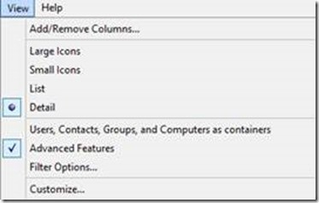

4. Right click the OU/Container you want the VCO to reside in and click “New” -> “Computer.” In the example below, we are creating the listener object in the Computers container.

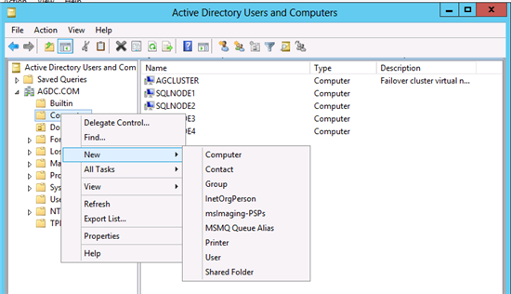

5. Provide a name for the object (this will be your listener name) and click “OK."

